Multi-tube Vortexer—MS400
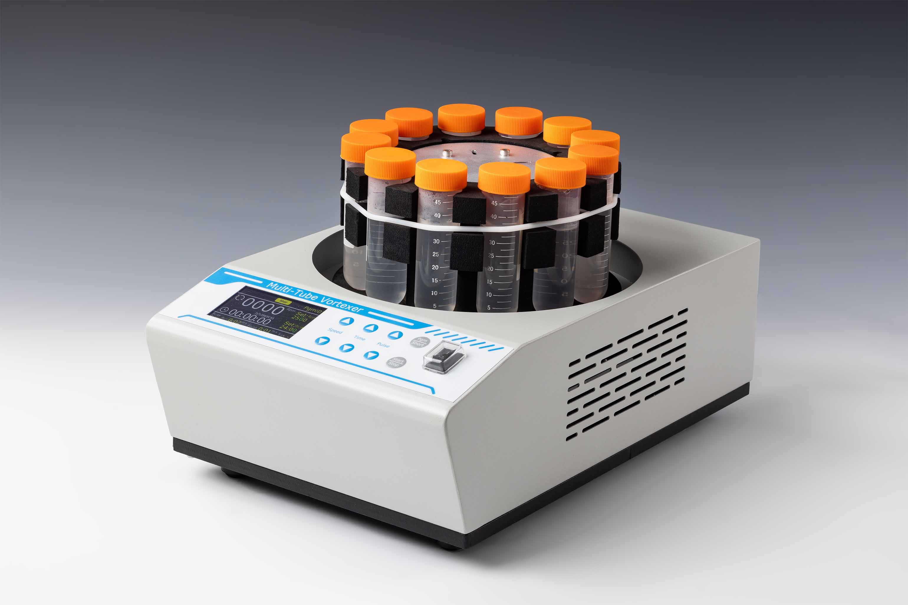

Description:
Multi-tube Vortexer is with technique of brushless DC motor and microprocessor controlled technique. It can maximum process 26 samples at once. It is suitable for different volume tubes and multi tube vortex, which mainly apply to the pretreatment of detections such as pesticide residues, veterinary drug residues, additives, mycotoxins, and environment.

Features:
- Colorful LCD displays time and shaking speed.
- 1min~99h59min time range, automatic warning sound when finish working.
- Pulsing program for interval mixing.
- Brushless DC motor: precise shaking speed, long service life maintenance-free.
- Process up to 26 samples at a time to make the experiment more convenient and efficient.
- Humanized program design, built-in timing/continuing/pulse/short mix operation modes.

Parameters
Project | Parameter
Speed range | 500~3000rpm
Orbit | 3mm
Time setting range | 1min~99h59min/∞
Pulse function | Yes
Timing set for pulse | 2s~9min59s
Interval timing between pulse | 1s~9min59s
Times for pulse | 1~99times
Pulse mode setting during running | Yes
Short mix | Yes
Max load | 4.5kg
Power supply | 150W
Voltage | AC100~240V/50-60Hz
Fuse | 250V 3A Ф5x20
Capacity | Type | Tube quantity | Tube diameter | Tube max. length
Capacity | MS400-T16 | 26 | ￠10~￠16mm | 160mm
Capacity | MS400-T32 | 12 | ￠16~￠32mm | 120mm
Dimension(mm) | 380x250x210
Weight(kg) | 14.3

